We set out to identify a causal effect of contribution amount (donations) on a candidate's percentage of votes received, and we've initially approached the question with the two techniques of outcome regression and inverse propensity weighting. With both methods we considered the same confounding variables with those being mostly binary features such as 'Veteran?,' 'LGBTQ?', and 'Elected Official? 'to name a few. Having established that percentage of votes has a more linear correlation with contribution amount logged than the raw contribution amount, we regressed percentage votes on logged contributions and confounding variables, and we estimated the treatment effect to be 4.20, implying that every 1% increase in contribution amount causes a 0.42% increase in percentage votes received.

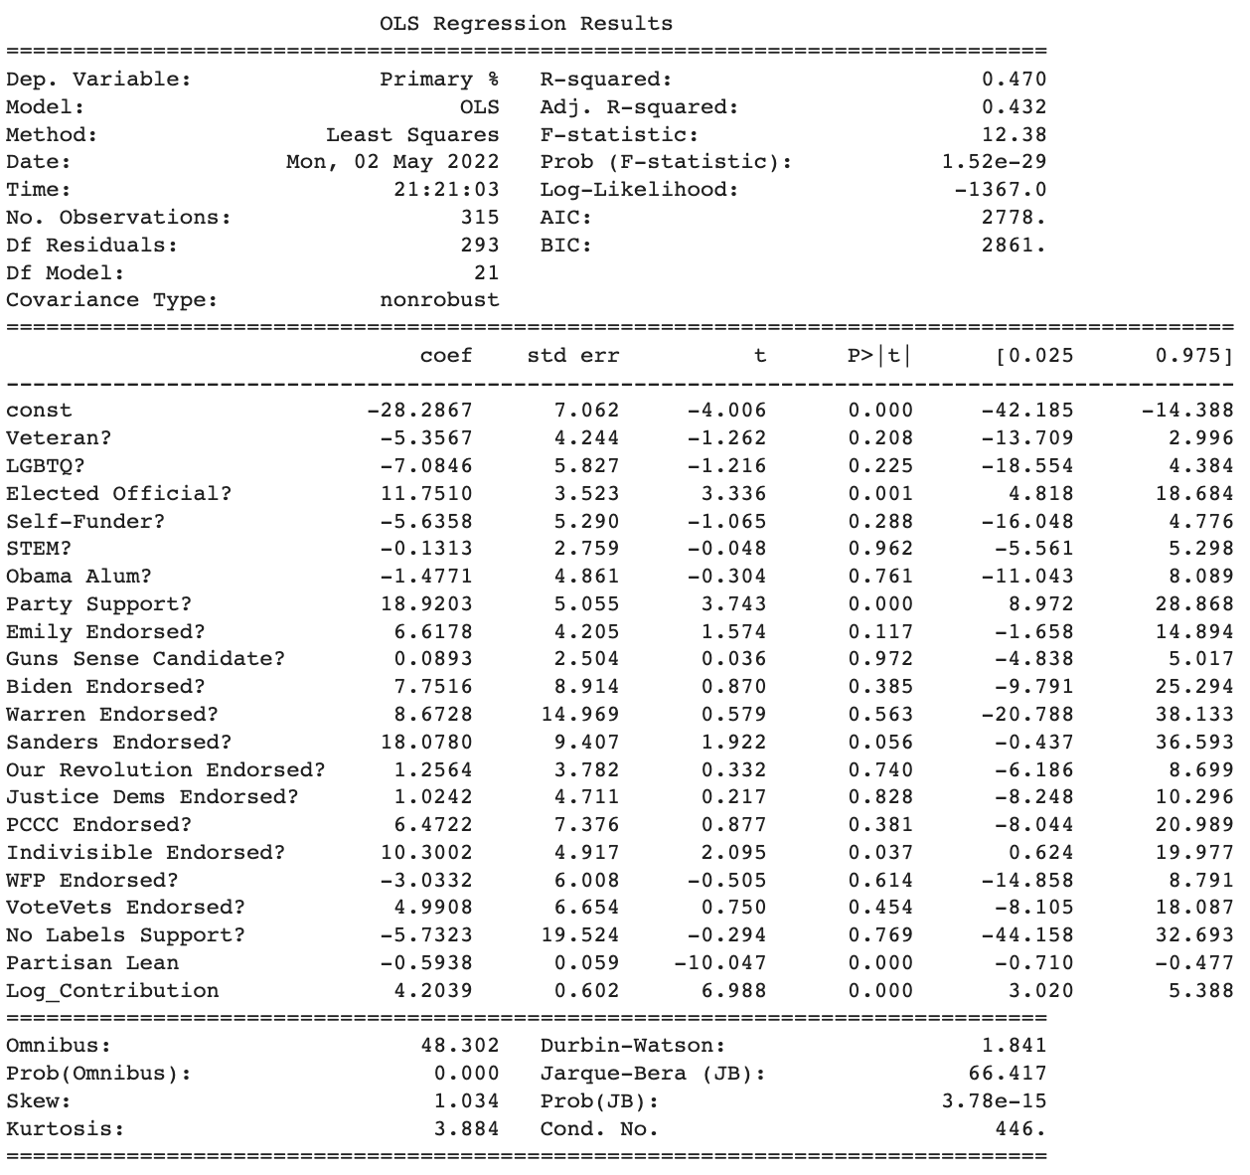

This measure of causal effect of contributions has some uncertainty- as seen in the table above, this effect ranges from 3.02 to 5.39.

Using inverse propensity weighting (including removing data points with propensity scores above 0.9 or below 0.1), we estimated the average treatment effect to be 16.19. This means that, all else being equal, the effect of a candidate receiving $1 million or more in contributions is expected to cause an increase in 16.19% of the vote in their expected primary. This indication of causality is based on the assumption that we have identified all of the confounding variables. While we did account for various candidate features, their endorsements by specific candidates and groups, and the partisan lean of the district they were running in, this may not be all of the confounders.

Both methods that we used imply that there is a causal relationship between campaign contributions and primary results. However we are uncertain about the validity of these results. As mentioned above, there are confounders that may not be accounted for. For example, how well-known the candidate is before the race could affect both primary results and contributions, and is not directly accounted for in our current factors. Another potential confounder is the state political environment; some races may occur in environments that are more anti-establishment, which could mean that political contributions from PACS or corporations may actually negatively affect primary performance. Confounders like these may mean that our hypothesis that there is a positive causal relationship between campaign contributions and primary performance may be incorrect.